Emic wave drive ion precipitation and Mev electron precipitation
Khz pulses produced by Mev electrons (kimura 2012)

Ions give x-ray, mev electrons give hhz

2min pulses likely produced by a wave interaction with mev electrons

EMIC , ion cycloton

Electron cyclotron is whistler waves, 1 type is chorus (ask zhonghua)
Chorus waves can gyroresonate with electrons and cause them to travel along the field lines or change the distribution, maybe producing radio waves

We see a nice correlation with slower and bigger waves, maybe we will see one with smaller and shorter waves

Dunn 2022 – Big spikes (7 counts), associated with UV flares in the banded region of the UV emissions, poleward of main oval but outside of swirl regions. In active region

Flickering emissions comes more poleward, in an arc shaped region (possibly a magnetopause boundary shape)

Arc moves equatorward during solar wind compressions, which is what an auroral mapping of the MP would do

Could try to link to show the arc is the MP, need Chandra, XMM and UV data

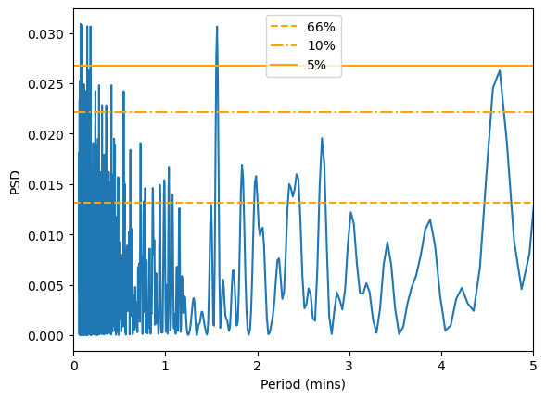
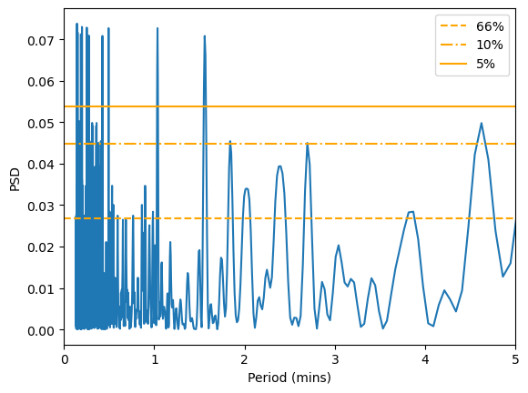
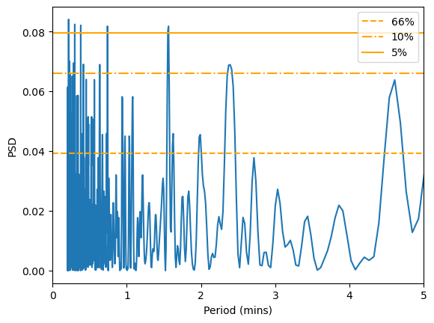

Does jupiter have flickering x-ray aurora on 1-2min timescales, (dunn et al 2022) and where does it map to?

Check juno data to the mapped region and look for driving mechanism

Check Chandra, and limit to flickering region

Compare spectra of big peaks and flickering (maybe show solar wind vs magnetospheric)

Produce random signatures and run through an FFT to see if we spuriously generate a 2min signature (e.g. 1mil times)

Check how lomb scargle false alarm prob works

Use an fft package and feed data to it, do shuffling – TESTING VALIDITY OF X-RAY SIGNAL

